# Life Expectancy Estimator

I built this app as a way to see how actuarial tables work and how health risks/benefits affect life expectancy. To start, you need a table of the probability of death at various ages. I found one from the [Social Security Administration](https://www.ssa.gov/oact/STATS/table4c6_2014.html), its Actuarial Life Table.

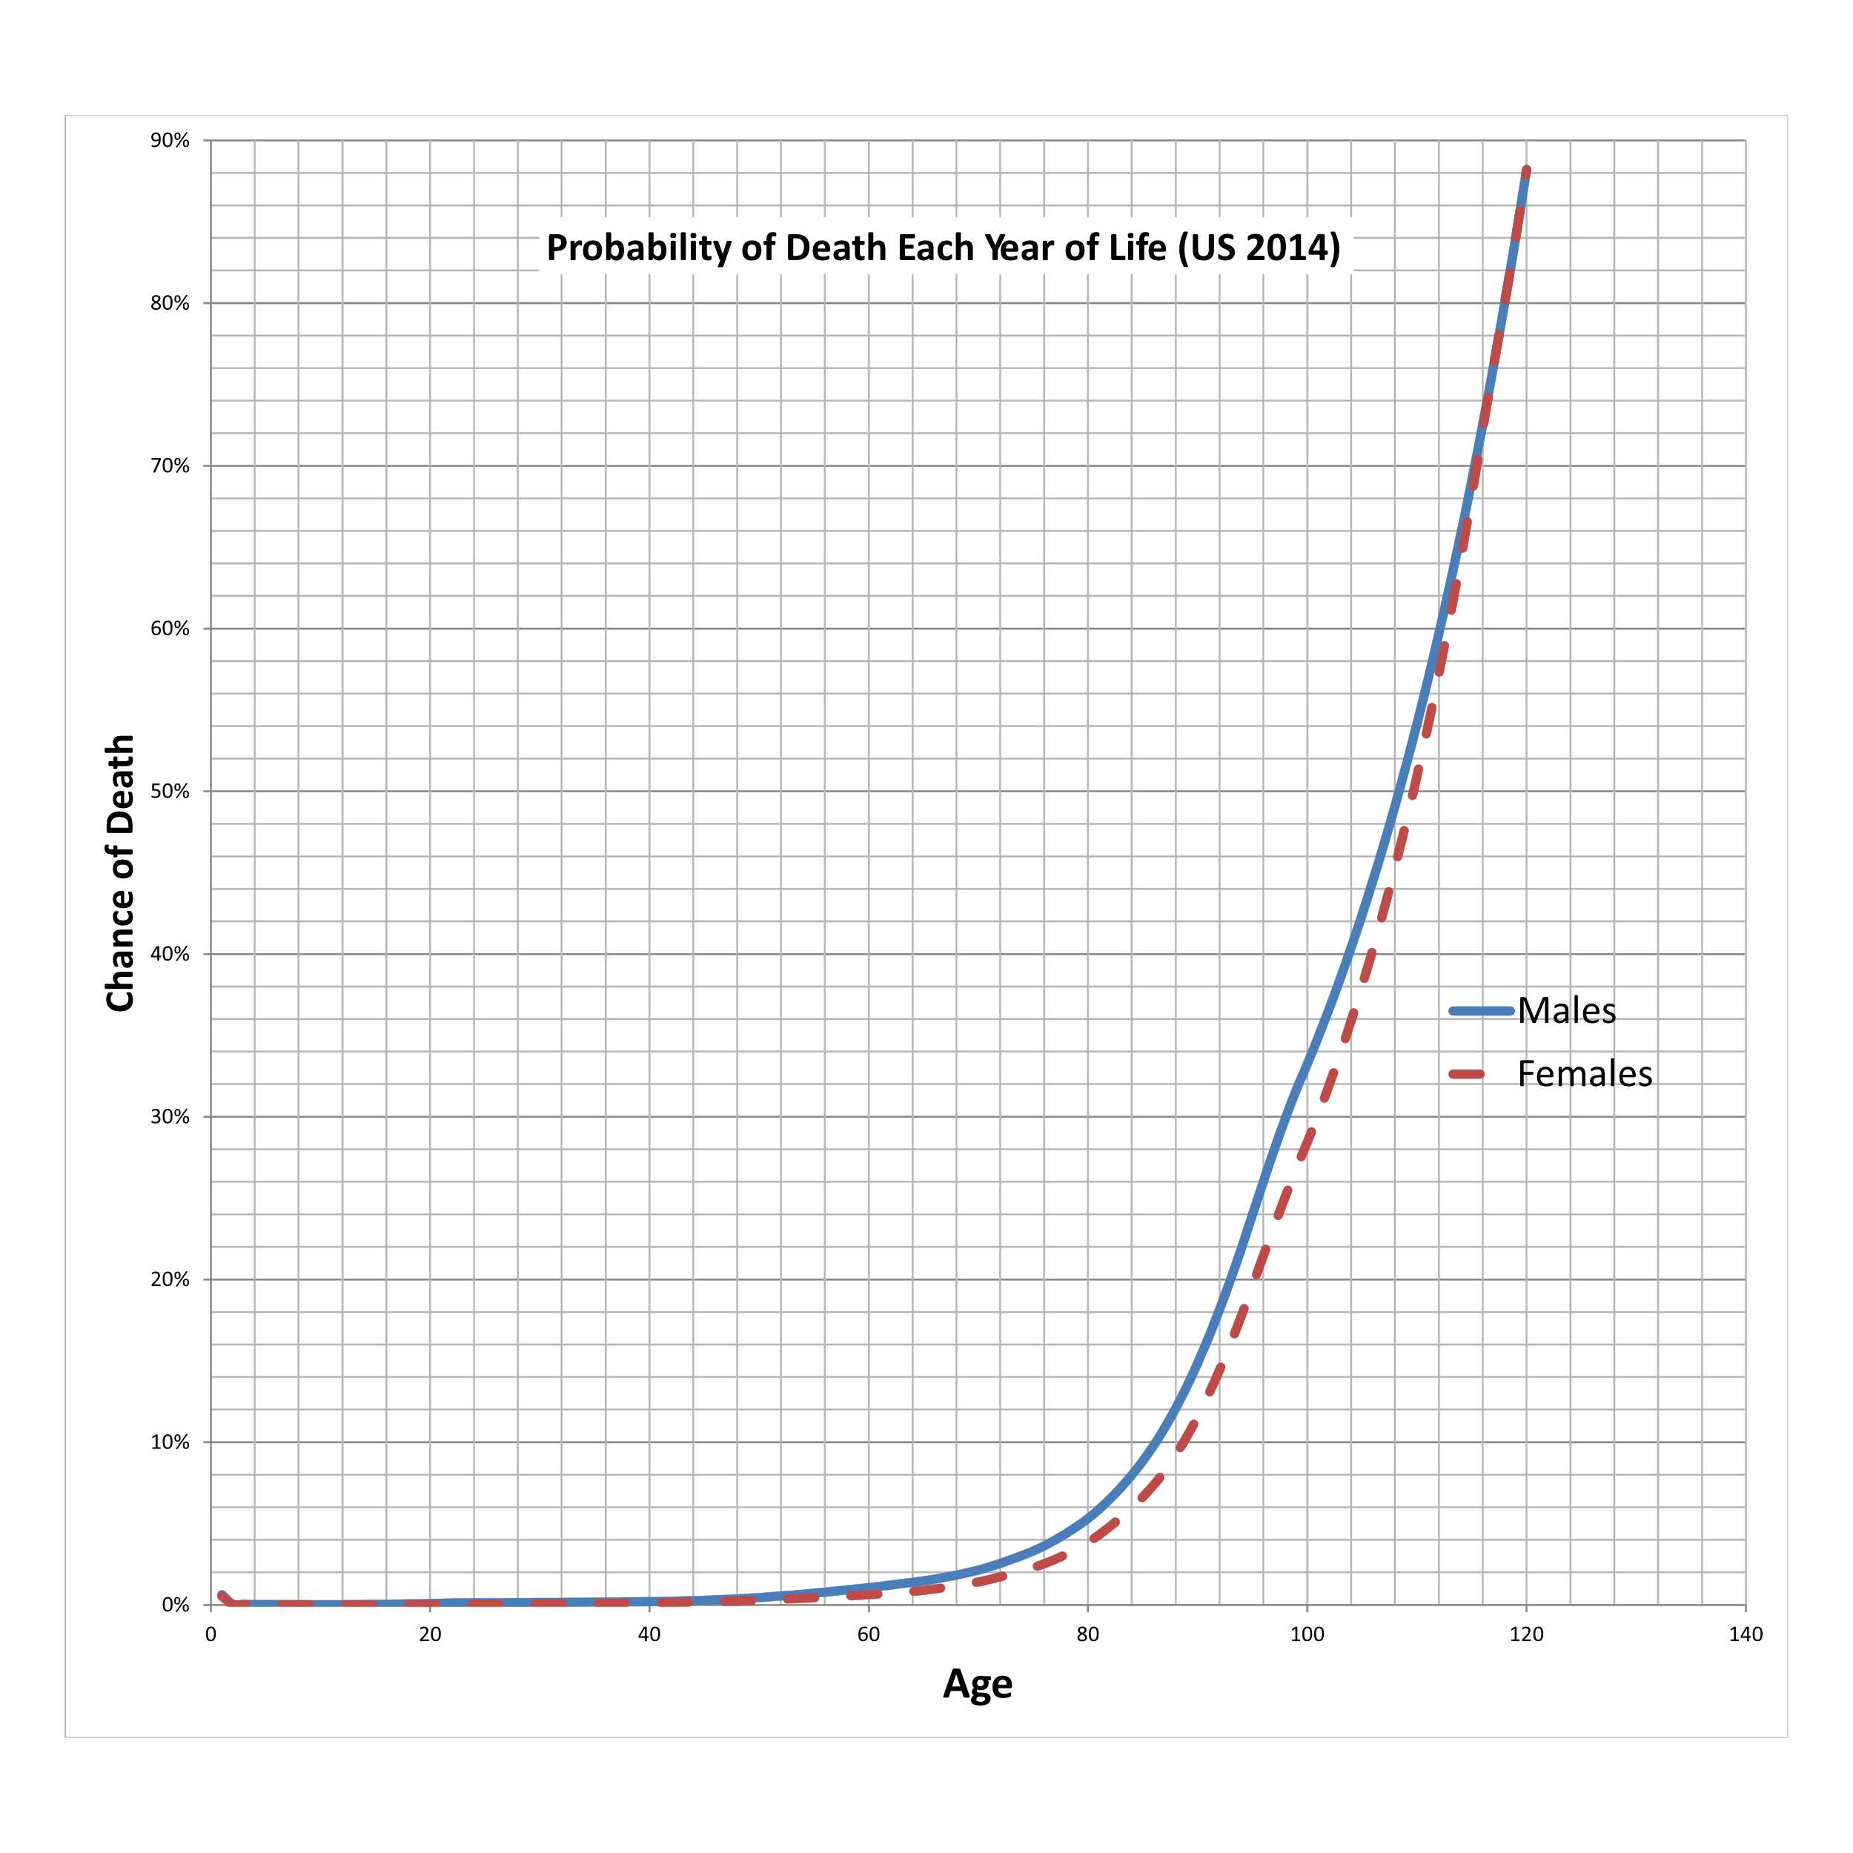

It is never helpful to compare very small risks. Better to talk of absolute risks. For example the risk of dying before age 50 is very small in absolute terms, but if you wanted to, you could look at the relative risk to men vs. women, for example, and think about the unfairness.

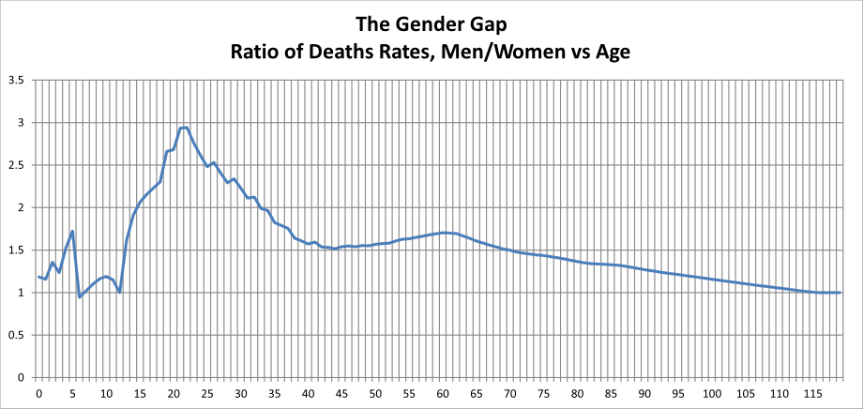

The real difference in outcome happens after 40 when the risk per year becomes much more significant, and men run a 1.5x higher risk. Watch the histogram in the app at about 60 years and switch between female and male. Watch the peak (mode) move. Certainly death isn’t ‘fair’ to men.

In the actuarial table they also have life expectancy, but for my purposes, I wanted to figure out how to recreate them. I used a large number of [random walk](https://en.wikipedia.org/wiki/Random_walk) simulations. In each run, the simulated person has a certain risk, given in the table, of dying each year. The risks build up each year until the simulated person dies, and I record their age. Most of the simulated people don’t make it past their 80s where the risk of dying each year is about 8-10%. Then, I create a histogram and analyze the mean, median, and mode. If you have forgotten, the mean is the average age. A life expectancy estimate based on the mean is weighted by large numbers of people who die early. The median is where a person reaches the 50% chance of living. The mode is the most common age when people die. I prefer to use the mean when looking at statistics and probabilities. I think the most intuitive is the mode, as in when you ask how long people live, they generally think about the most common ages when others die. Here is [another article](https://obliviousinvestor.com/mean-vs-median-life-expectancy-for-retirement-planning/) on this issue.

My main reason to create this analysis is to study the effect of additional, or reduced, risk on life expectancy. If an advertisement, a doctor, or the news tells you that a medicine/treatment/diet reduces your risk of death, you should pay it no attention until you find the “all cause mortality” risk ratio. For [example](https://health.gov/sites/default/files/2019-09/Physical_Activity_Guidelines_2nd_edition.pdf#page=43), “It has been estimated that people who are physically active for approximately 150 minutes a week have a 33 percent lower risk of all-cause mortality than those who are not physically active.” A 33 percent lower risk, assuming the general population is not physically active, means a risk ratio of 1-0.33 = 0.67 compared to the general population. Plugging this into the Life Expectancy Estimator means that a male who is 50 years old would improve their median life expectancy by 4 years (from 80 to 84 years). On the other hand, all-cause mortality risk for drinking [25 drinks a week is about 1.45](https://www.thelancet.com/journals/lancet/article/PIIS0140-6736(18)30134-X/fulltext), results in a decrease from a median life expectancy of 5 years (from 80 to 75 years).

Starting age can be adjusted, and you will note that if you survive to a greater age, your life expectancy is subsequently higher.

Cheers,

Burney